**Task 8 – Working and Understanding VPN**

**Install Proton VPN**

Click on the link and download proton VPN - [Proton VPN](https://protonvpn.com/free-vpn/windows?srsltid=AfmBOoqiUpWRCwE994EOWNqx2_iGCE2jFWEiKV9yAm8MxQfr0YK81suY).

After installing the VPN, create a free account.

Verify the email address.

Open the VPN client installed and sign-in using the free account created.

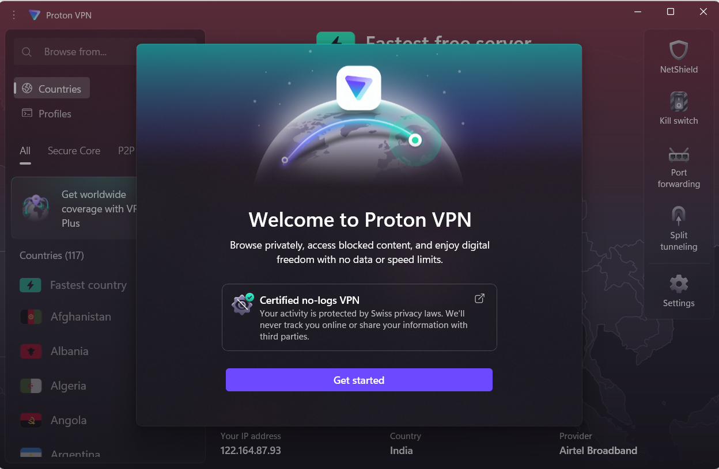

Click on get started. The below screen will be displayed.

**Using Proton VPN**

Click on Connect button to connect to a VPN server.

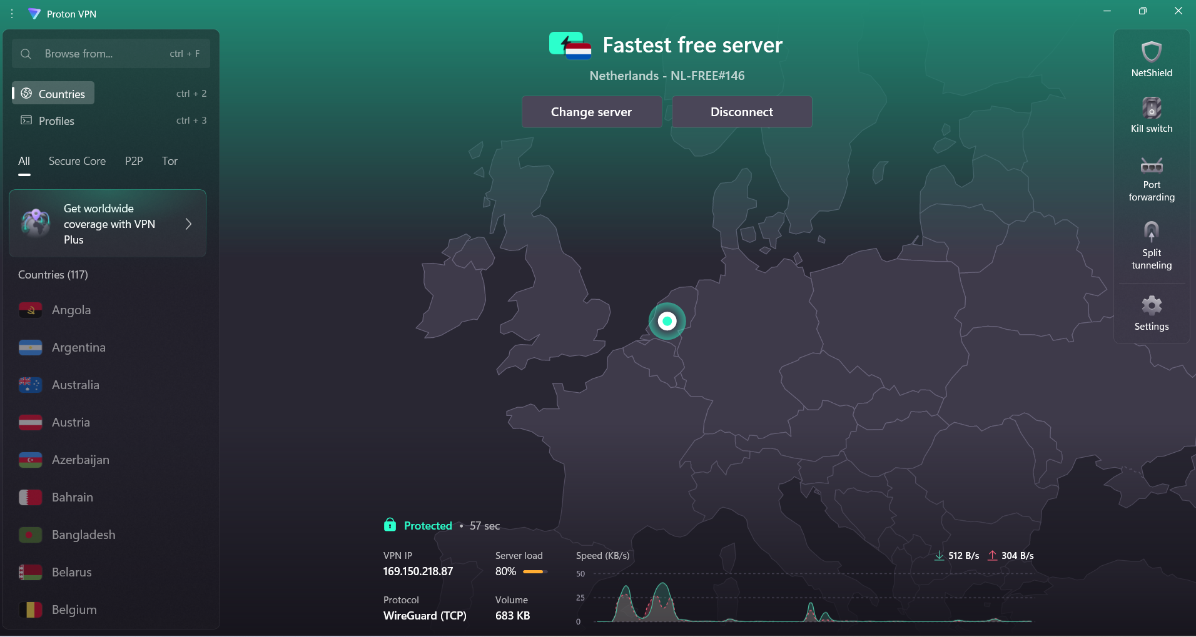

Click on the change server button. It takes some time to connect to a different VPN server.

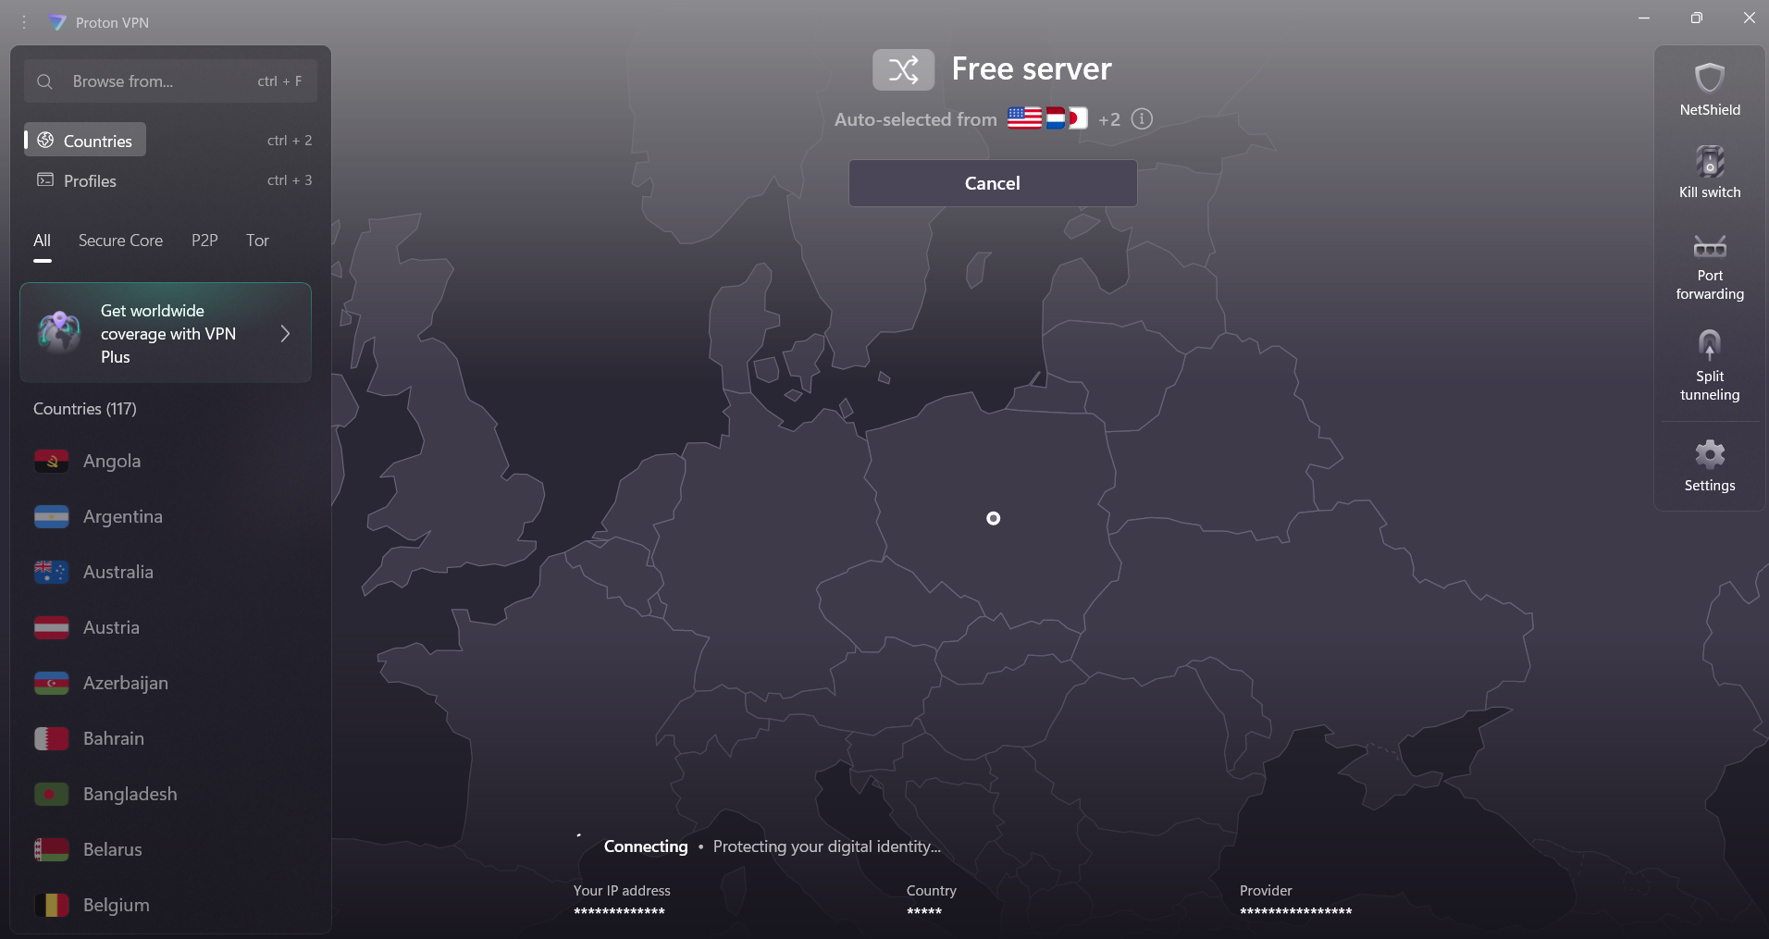

Now, the server is changed from Netherlands to Poland.

After connecting to VPN, the IP address of the device is changed to the server address mentioned on the VPN.

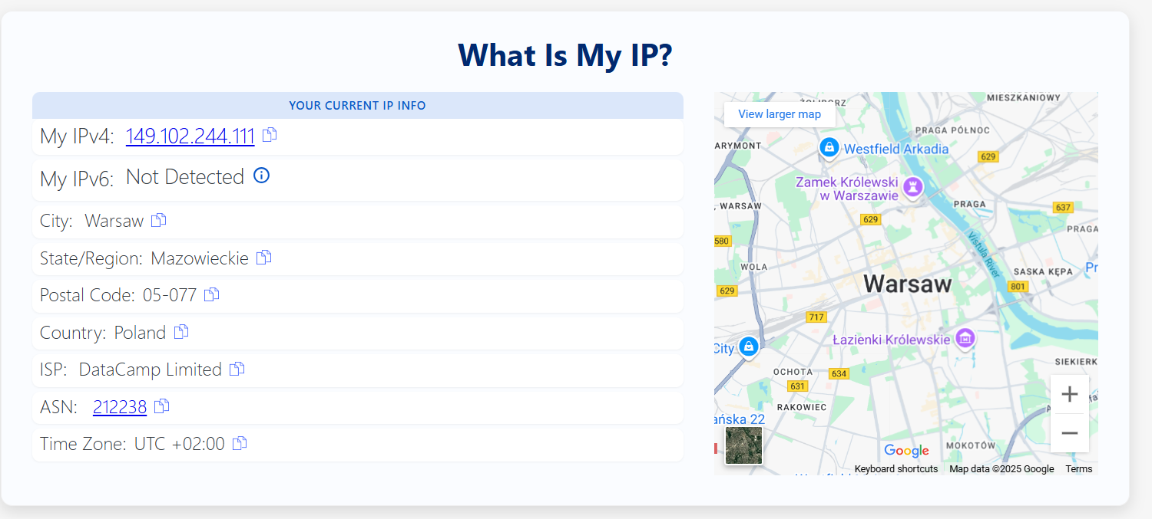

Disconnected the VPN and checked the IP address.

The browsing speed seems to be similar with and without using VPN.

The traffic using VPN is encrypted as I used wireshark to capture packets I couldn’t get any useful logs out of it. Not the protocol or DNS information is available.

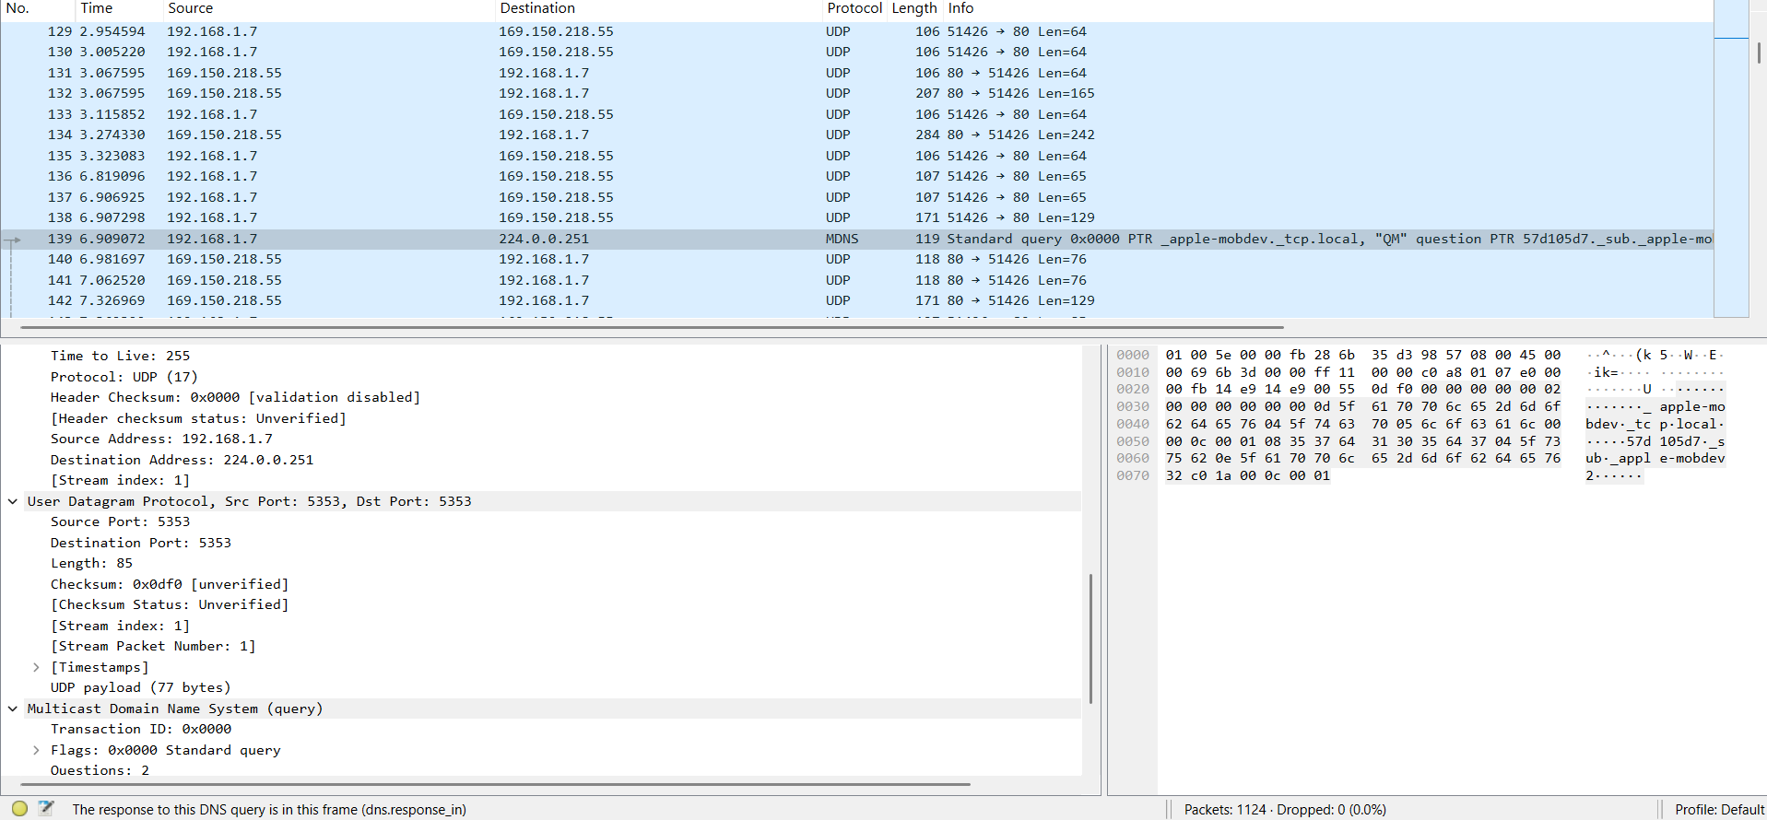

The wireshark capture without VPN here shows that DNS is used for accessing youtube.com.



**VPN Benefits**

* **Privacy:** Hides your IP address and encrypts your internet traffic, preventing monitoring by ISPs, hackers, and trackers.
* **Security:** Protects your data on public Wi-Fi and enhances overall online security.
* **Access:** Bypasses geo-restrictions and censorship to access blocked content and services.
* **No Throttling:** Can prevent your ISP from slowing down your connection based on your activities.

**VPN Limitations**

* **Speed Impact:** Can slightly slow down your internet connection due to encryption and routing.
* **Not All-Encompassing Security:** Doesn't protect against malware, viruses, or phishing; requires other security measures.
* **Trust Required:** Your privacy depends on the VPN provider's "no-logs" policy and their own security practices.
* **Can Be Blocked:** Some services or countries actively detect and block VPN usage.
* **Cost & Legality:** Quality VPNs cost money, and their use is illegal or restricted in some regions.